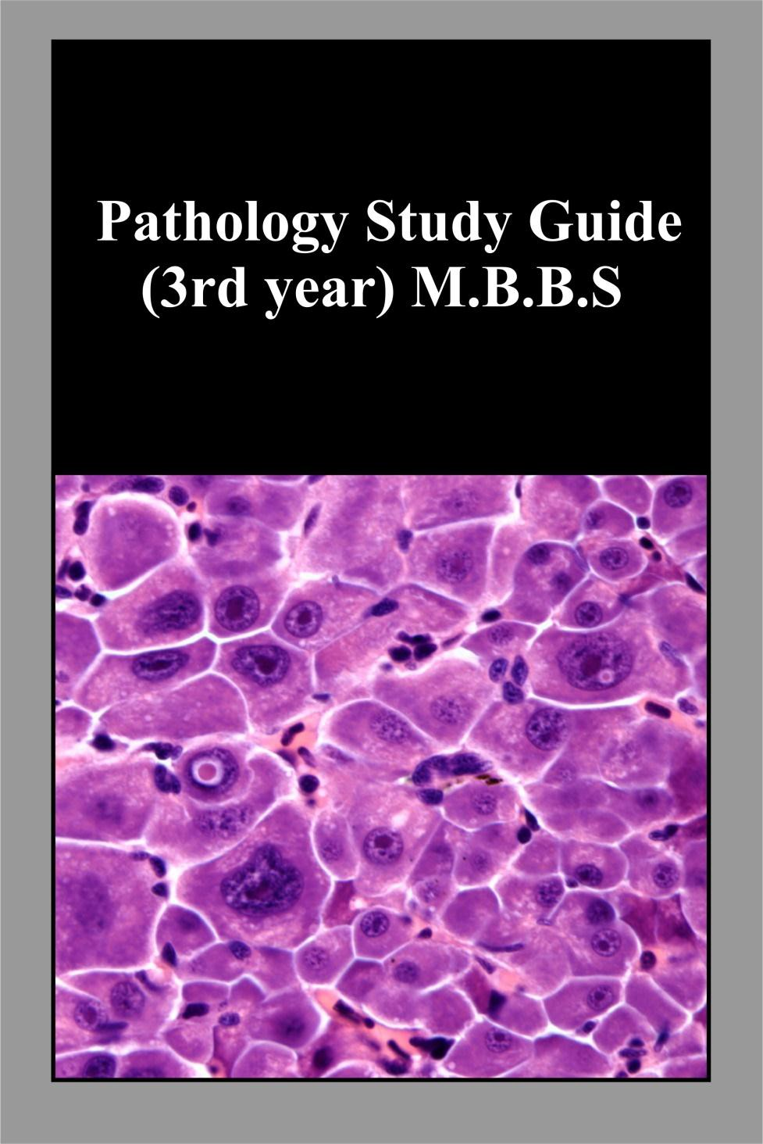
STUDY GUIDE PATHOLOGY

TABLE OF CONTENTS

CONTENT |  | Page No.
1 | Pathology department in a glance | 3
2 | Pathology department team- AFMDC | 5
3 | Gantt’s chart | 6
4 | Time Table | 7
5 | Learning objectives | 8
6 | Examination | 22
7 | Table of specification | 23
8 | Textbooks | 24

INTRODUCTION OF PATHOLOGY
Pathology is the branch of medicine concerned with the study of the nature of diseases and its causes, processes, development and consequences. The medical specialty that provides microscopy and other laboratory services (e.g. cytology, histopathology) to Clinicians.
The pathologist is interested not only in the recognition of structural alterations, but also in their significance, i.e. the effects of these changes on cellular and tissue function and ultimately the effect of these changes on the patient. It is a basic approach to a better understanding of disease and therefore a foundation of sound clinical medicine.
The department of pathology is headed by Prof. Dr M Kashif Baig along with two Associate Professors one Assistant Professor and five Demonstrators, all of them are actively involved in teaching programs. The department comprise of general and special pathology including histopathology, hematology, microbiology and chemical pathology. Teaching of general pathology principal are supplemented by experimental work by which students are equipped with the skills required for the collection of different specimens for the pathological analysis and then are able to perform commonly used tests done in a side room laboratory. The aim is to produce clinicians with better understanding of the disease process so that they objectively use diagnostic tools designed to help them to reach a conclusive diagnosis in the shortest possible time.
The department has an adequate slide bank and gross specimen collection for the teaching purposes. This department is also equipped with a Penta Head microscope with LCD display screen and a bihead microscope for proper explanation of the microscopic slides. Binocular microscopes are also available for students proper training. The department also has two labs along with experienced teachers and technical staff.
The academic session includes lectures, practical microbiology, histopathology slide discussions, museum classes, tutorials and small group discussions for MBBS students. Pathology is taught during the third and fourth years of the MBBS program. The students will be evaluated internally and externally. The department has a well – designed museum displaying neatly mounted specimens and several detailed and highly informative charts / graphs.

Department of Pathology

Designation |  | Name
HOD/Professor |  | Dr M Kashif Baig
Associate Professor |  | Dr Usman  Dr Khalid
Assistant Professor |  | Dr Javaid
Demonstrators |  | Dr Iram  Dr Madeeha Dr Amna  Dr Kiran  Dr Munaim
Lab Assistant / Lab Tech |  | Rehman Dastgeer (Lab Tech),  M. Waseem (Assistant Lab Tech)  M. Asif & M. Haseeb Ahmad (lab Attendant)
Comp Operator |  | Hammad Hassan

TIME LINE for SYLLABUS COMPLETION GANTT CHART of 3rd YEAR LECTURES
Topic | Nov |  | Dec |  | Jan |  | Feb | Mar | Apr | May | Jun |  |  | Jul | Aug
The Cell, Cellular Response + GB
Cellular Response + GB + SB
Inflammation Repair + SB
Hemodynami cs + SB
Hemodynami cs + Neoplasia + SB +
Parasitology
Neoplasia + Immune System + Parasitology
+ Virology
Immune System + Virology
Virology + Revision Lectures
Revision Lectures

Key:

Winter Vacations GB= General Bacteriology
SB= Special Bacteriology
Sports Week Summer Vacations Eid Ul Adha Sendup Exam

TIME TABLE

Day | 1 | 2 |  | 3 | 4 | 5 |  | 6 | 7 |  | 8
 | 08:00-08:45 | 08:45-  09:30 |  | 09:30-10:15 | 10:15-11:00 | 11:00-01:00 |  | 01:00-01:30 | 13:30-15:00
Mon | Test |  |  | Pharmacology | Pathology | Practical  A: Pharma  B: Pathology  C: F.Medicine |  | Z  O  H  A  R  B  R  E  A  k | Practical  B: Pharma  C: Pathology  A: F.Medicine
Tues | EYE/Behavioral Sciences |  | Behavioral Sciences | Tutorial  A: Pharma  B: Pathology  C: F.Medicine |  | Practical  C: Pharma  A: Pathology  B: F.Medicine |  |  | Patho. | F.Med.
 | 08:00-08:45 |  | 08:45-  09:30 | 09:30-11:00 |  | 11:00-12:45 |  |  | 13:30-14:15 |  |  | 14:15-15:00
Wed | Medicine and Allied |  | Pharmacology | Tutorial  B: Pharma  C: Pathology  A: Forensic Medicine |  | Ward |  |  | F.Med |  |  | Patho
Thur | Forensic Medicine |  | Surgery and Allied | Tutorial  C: Pharma  A: Pathology  B: F.Med. |  | Ward |  |  | Pharma |  |  | Patho
Fri | ENT/ Behavioral Sciences |  | Pathology | Forensic Medicine | Pharmaco  logy | Ward |  |  | Jumma  Prayers |  |  | Self-Study/  Mentoring
Monthly Class Test Schedule |  |  | Subject | Ward Program: 8 Groups
 |  |  |  | Group 1: Anesthesia Group 5: Eye
1st Monday |  |  | Pathology | Group 2: Behavioral Science |  |  | Group 6: Medicine
2nd Monday |  |  | Forensic | Group 3: Em. Medicine |  |  | Group 7: Orthopedics
3rd Monday |  |  | Pharmacology | Group 4: ENT |  |  | Group 8: Surgery
4th Monday |  |  | B.S | Ward Rotation for 4 weeks each/Ward test on last day of rotation.

Table of learning outcomes and teaching strategies in General Pathology and Microbiology

TOPIC | SUBTOPIC | LEARNING OBJECTIVES
The Cell as a Unit of Health and disease | Cellular Housekeeping | Describe the structure of Plasma Membrane
 |  | Describe the components of Cytoskeletonalong with Cell- Cell Interactions
 |  | Describe the Biosynthetic Machinery of cell ( Endoplasmic Reticulum and Golgi )
 |  | Describe the structure and function of Lysosomes and Proteasomes
 |  | Describe the Cellular Metabolism along with mitochondrial function
 | Cellular Activation | Describe Cell Signaling and its mechanism
 |  | Describe various types of Signal Transduction Pathways
 |  | Enlist various types Growth Factors and Receptors with their function
 |  | Describe the Interaction of intracellular and the Extracellular Matrix
 | Maintaining Cell Populations | Explain the Proliferation and the Cell Cycle along with role of inhibitors and inducers
 |  | Describe the role of Stem Cells in recent medicine
Cellular Responses to Stress and Toxic Insults: Adaptation, Injury, and Death | Introduction to Pathology | Define pathology
 |  | Describe the four aspects of pathology
 |  | 1. Etiology
 |  | 2.Pathogenesis
 |  | 3.Morphology
 |  | 4. Clinical manifestations
 | Overview: Cellular Responses to Stress | Enlist the Stages of the cellular response to stress and injurious stimuli.
 | and Noxious Stimuli | Describe the Stages of the cellular response to stress and injurious stimuli.
 | Adaptations of Cellular Growth and differentiation
 |  | Enlist the types of cellular adaptations
 |  | Describe the mechanism of hypertrophy with examples
 |  | Describe the mechanism of hyperplasia with examples
 |  | Describe the mechanism of atrophy with examples
 |  | Describe the mechanism of metaplasia with examples
 | Overview of Cell Injury and Cell | Enlist various Causes of Cell Injury
 |  | Describe the mechanism of Reversible Injury

 | death | Define Necrosis
 |  | Describe various Patterns of Tissue Necrosis
 | Mechanisms of Cell Injury | Describe Depletion of ATP with illustration
 |  | Describe Mitochondrial Damage with illustration
 |  | Describe Influx of Calcium and Loss of Calcium Homeostasis with illustration
 |  | Describe the mechanism of Oxidative Stress in the cell and the injury caused by it
 |  | Describe the defects in membrane permeability
 |  | Describe the damage to DNA and proteins
 | Clinicopathologi c Correlations | Describe the mechanism of Ischemic and Hypoxic Injury
 |  | Describe the mechanisms of ischemic cell injury
 |  | Describe the Ischemia-Reperfusion Injury
 |  | Describe the Chemical (Toxic) Injury to cell
 | Apoptosis | Define Apoptosis
 | Causes of Apoptosis | Describe the process of apoptosis in physiologic situations
 |  | Describe the apoptosis in pathologic conditions
 | Morphologic and Biochemical Changes in Apoptosis | Describe the following two Mechanisms of Apoptosis with illustrations
 |  | 1.The Intrinsic (Mitochondrial) Pathway of Apoptosis
 |  | 2. The Extrinsic (Death Receptor-Initiated) Pathway of Apoptosis
 |  | Describe the execution phase of apoptosis
 |  | Describe the process of removal of dead cells
 | Clinicopathologi c Correlations: Apoptosis in Health and Disease | Describe the examples of apoptosis
 |  | Describe the disorders associated with dysregulated apoptosis
 |  | Describe the process of heterophagy and autophagy
 |  | Describe the process of Necroptosis with examples
 | Intracellular Accumulations | Describe the pathogenesis and morphology of following intracecullar accumulations
 |  | 1. Lipids Steatosis (Fatty Change)
 |  | 2. Cholesterol and Cholesterol Esters
 |  | 3. Proteins
 |  | 4. Hyaline Change
 |  | 5. Glycogen
 | Pigments | Enlist the types of exogenous pigments and endogenous pigments
 |  | Describe the morphological features of various types of pigments
 | Pathologic Calcification | Describe the pathogenesis , and morphology of Dystrophic Calcification
 |  | Describe the pathogenesis , and morphology of Metastatic Calcification

 |  | Describe the etiology of Cellular Aging and cellular senescence
 |  | Demonstrate the working of microscope
Inflammation and Repair | Overview of Inflammation: Definitions | Enlist and briefly describe Causes of Inflammation
 | and General Features | Explain and Illustrate the Recognition of Microbes and Damaged Cells
 | Acute Inflammation | Describe the reactions of blood vessels in acute inflammation
 |  | Describe the changes in vascular flow and caliber
 |  | Explain mechanism of increased vascular permeability (Vascular Leakage)
 |  | Describe the responses of lymphatic vessels and lymph nodes
 | Leukocyte Recruitment to Sites of Inflammation | Describe the mechanism of leukocyte adhesion to endothelium
 |  | Describe the mechanism of leukocyte migration through endothelium
 |  | Describe the mechanism of chemotaxis of leukocytes
 | Phagocytosis and Clearance of the Offending Agent | Describe the mechanism of Phagocytosis
 |  | Describe the role of Intracellular destruction of microbes and debris
 |  | Define Neutrophil Extracellular Traps
 |  | Describe the Leukocyte-mediated tissue injury and associated defects
 | Termination of the Acute Inflammatory Response | Describe the termination of the response
 | Mediators of Inflammation | Describe the role and source of mediators;
 |  | 1. Vasoactive Amines: Histamine and Serotonin
 |  | 2. Arachidonic Acid Metabolites
 |  | 3. Cytokines and Chemokines
 |  | 4. Complement System
 | Morphologic Patterns of Acute Inflammation | Explain the morphological pattern and example of Serous Inflammation
 |  | Explain the morphological pattern and example of Fibrinous Inflammation
 |  | Explain the morphological pattern and example of Purulent (Suppurative) Inflammation, Abscess
 |  | Explain the morphological pattern and example of Abscess and ulcer
 | Outcomes of Acute | Summarize the events of Acute Inflammation

 | Inflammation
 | Chronic Inflammation | Enlist the Causes of Chronic Inflammation
 |  | Describe the morphologic features of chronic inflammation
 | Cells and Mediators of Chronic Inflammation | Explain the role of macrophages in chronic inflammation
 |  | Explain the role of Role of Lymphocytes
 |  | Enumerate the other cells in chronic inflammation
 | Granulomatous Inflammation | Describe the etiology, pathogenesis and morphology of granuloma
 | Systemic Effects of Inflammation | Enumerate the systemic effects of inflammation
 | Tissue Repair
 | Overview of Tissue Repair | Describe the control mechanisms in cell proliferation
 |  | Describe the Mechanisms of Tissue Regeneration
 | Repair by Connective Tissue Deposition | Enumerate the Steps in Scar Formation
 |  | Describe the process of angiogenesis
 |  | Explain the Deposition of Connective Tissue in tissue remodeling
 |  | Explain the mechanism of Remodeling of Connective Tissue
 | Factors That Influence Tissue Repair | Enumerate all local and systemic factors for tissue repair
 | Selected Clinical Examples of Tissue Repair and fibrosis | Describe Healing of Skin Wounds both primary and secondary
 |  | Explain mechanism of Fibrosis in Parenchymal Organs
 | Abnormalities in Tissue Repair | Describe the formation of keloid ad hypertrophic scar
 |  | Describe the formation of exuberant formation and desmoids
Hemodynamic disorders, | Edema and Effusions | Discuss the causes of increased hydrostatic pressures
Thromboembolic Disease and |  | Discuss the causes of reduced plasma osmotic pressures
shock |  | Discuss the causes of sodium and water retention
 |  | Discuss the causes of lymphatic obstruction
 |  | Identify pathophysiological categories of Edema
 |  | Explain the morphology and clinical features of Edema
 | Hyperemia and Congestion | Explain the differences of the terms hyperemia and congestion morphologically
 | Hemostasis, Hemorrhagic disorders and | Define the term Hemostasis and explain the sequence of events leading to hemostasis
 |  | Relate the role of platelets in maintaining hemostasis

 | thrombosis | Revise the coagulation cascade
 |  | Discuss in detail the significance of Endothelium in maintaining Hemostasis
 |  | Introduction to the term Hemorrhagic Disorders
 |  | Explain the etiology, pathogenesis and morphology of thrombosis
 |  | Discuss the effects of endothelial injury
 |  | Describe in detail the effects of alternations in normal blood flow
 |  | Associate hypercoagulability with thrombus formation
 |  | Discuss in detail the fate of thrombus
 |  | Explain the process of Disseminated intravascular coagulation
 |  | Discuss the pathophysiology and morphology of DIC
 | Embolism | Introduction to the term embolism
 |  | Discuss the etiology, pathogenesis and morphology of pulmonary embolism
 |  | Discuss the etiology, pathogenesis and morphology of systemic thromboembolism
 |  | Discuss the etiology, pathogenesis and morphology of fat and marrow embolism
 |  | Discuss the etiology, pathogenesis and morphology of air embolism
 |  | Discuss the etiology, pathogenesis and morphology of amniotic fluid embolism
 | Infarction | Explain the mechanism of infarction
 |  | Discuss the factors that lead to development of infarct and its morphology
 | Shock | Discuss the pathogenesis of septic shock
 |  | Describe all stages of shock, morphology and clinical consequences
Genetics | Genes and human diseases | Discuss in detail mutations
 |  | Define Mendelian disorders
 | Single gene disorders | Discuss the transmission patterns of autosomal dominant disorders
 |  | Discuss the transmission patterns of autosomal recessive disorders
 |  | Discuss the transmission patterns of X-linked disorders
 | Biochemical and molecular | Discuss the enzyme defects and their consequences with example ( lysosomal and glycogen storage diseases)
 |  | Discuss the disorders of structural proteins(Marfan Syndrome, EDS)
 | basis of single gene disorders | Discuss the defects in receptors and transport system with example (familial hypercholesterolemia)
 |  | Brief review of alteration in structure, function or quantity of nonenzyme proteins

 |  | Brief review of genetically determined adverse reaction to drugs
 | Chromosomal Disorders | Discuss cytogenetic disorders involving autosomes(Downs Syndrome, deletion syndrome)
 |  | Discuss cytogenetic disorders involving sex chromosomes(Klinefelter Syndrome, Turner syndrome)
 |  | Define the terms hermaphroditism and pseudo hermaphroditism
 | Single gene disorders with | Define the diseases associated with single gene mutations
 | noncalssical inheritance
 | Molecular Genetics Diagnosis | Explain the diagnostic methods (PCR,FISH,MLPA)
 |  | Discuss polymorphic markers and molecular diagnosis, RNA Analysis
Neoplasia | Nomenclature | Explain the terms differentiation and anaplasia
 |  | Explain the terms local invasion and metastasis
 |  | Briefly explain pathways of spread of tumors
 |  | Discuss features of benign and malignant neoplasms
 |  | Differences of benign and malignant neoplasms
 | Epidemiology of cancer | Discuss the global impact of cancer
 |  | Discuss the role of environmental factors in development of cancer
 |  | Discuss in detail age, acquired predisposing conditions
 |  | Explain the genetic predisposition and interaction between inherited and environmental factors
 | Molecular basis of cancer | Discuss role of genetic and epigenetic alterations
 |  | Describe cellular and molecular hallmarks of cancer
 |  | Explain the self-sufficiency in growth signals
 |  | Describe the terms, oncogenes, proto- oncogenes, oncoproteins
 |  | Explain the insensitivity to growth inhibition
 |  | Explain the growth promoting metabolic alterations
 |  | Explain Warburg effect
 |  | Discuss in detail the evasion of programmed cell death(APOPOTOSIS)
 |  | Associate limitless replicative potential with tumor growth
 |  | Explain the role of angiogenesis, invasion and metastasis in development of tumor
 |  | Discuss the evasion of host defense, genomic instability
 |  | Illustrate with examples cancer enabling inflammation
 |  | Discuss dysregulation of cancer associated gene(chromosomal changes, epigenetic changes and non- coding RNA's)
 | Carcinogenic | Role of chemical carcinogenesis and steps involved in

 | Agents | development of cancer
 |  | Describe direct acting carcinogens
 |  | Describe indirect acting carcinogens
 |  | Explain the role of radiation carcinogenesis(UV rays, ionizing RADIATION)
 |  | Discuss the microbial carcinogenesis
 | Clinical Aspects of Neoplasia | Explain the grading and staging of tumors
 |  | Discuss laboratory diagnosis of cancer
 |  | Explain the tumor markers in detail
General Bacteriology | Introduction | Recall bacteria
 |  | Discuss important features of microbes
 |  | Describe characteristics of prokaryotic and eukaryotic cells
 | Structure of bacteria | Discuss shape and size of bacteria
 |  | Discuss cell wall and its components
 |  | Compare cell wall of gram positive and gram negative
 |  | Describe bacterial spores and their importance
 |  | Discuss cytoplasmic structure and its components
 | Growth | Define Binary fission
 |  | Discuss growth cycle and curve and its phases
 |  | Discuss aerobic and anaerobic growth
 |  | Discuss fermentation and iron metabolism
 | Genetics | Define genetics
 |  | Discuss mutation and its types
 |  | Discuss transfer of DNA within bacterial cell
 |  | Discuss transfer of DNA between bacterial cell
 |  | Discuss recombination and its types
 | Classification of important bacteria | Discuss principles of classification
 |  | Classify bacteria on different basis
 | Normal flora | Define normal flora
 |  | Enlist normal flora with their anatomical sites
 |  | Discuss medical importance of normal flora
 |  | Define commensals, carrier state, colonization and resistance
 | Pathogenesis | Define pathogen, virulence, infectious dose, parasite and types
 |  | Describe types of bacterial infections
 |  | Enlist stages of bacterial infection
 |  | Discuss determinants of bacteria
 |  | Enumerate different strains of bacteria causing disease
 | Host Defense | Define innate and acquired immunity
 |  | Describe host defenses against bacteria
 |  | Describe components of acquired and innate immunity
 | Laboratory diagnosis of | Discuss approach to laboratory work
 |  | Discuss approach to serological testing

 | bacteria | Describe specimen taking for different cultures
 |  | Discuss commonly used bacterial agars
 |  | Discuss different methods of diagnosis based on nucleic acid analysis
 | Bacterial vaccine | Enlist general principles of bacterial vaccines
 |  | Describe active and passive immunity
 |  | Enlist common bacterial vaccine
 | Sterilization and Disinfection | Define sterilization and disinfection
 |  | Discuss methods of sterilization and disinfection
 |  | Identify instruments/agents/machine used in sterilization
General virology | Introduction | Recall virus
 |  | Discuss important properties
 |  | Enlist comparison of viruses and cell
 | Structure of virus | Discuss shape and size of virus
 |  | Discuss different component of virus
 | Classification of virus | Discuss principle of classification
 |  | Enumerate classification of virus
Special virology |  | Define herpes virus
DNA enveloped virus | Herpesvirus | Demonstrate features, transmission, pathogenesis, diagnosis, prevention
 | Herpes simplex virus | Demonstrate features,transmission,pathogenesis,diagnosis,prevention
 | Varicella-Zoster virus | Demonstrate features,transmission,pathogenesis,diagnosis,prevention
 | Cytomegalovirus | Demonstrate features,transmission,pathogenesis,diagnosis,prevention
 | Epstein-barr virus | Demonstrate features,transmission,pathogenesis,diagnosis,prevention
 | Human herpesvirus8 | Demonstrate features,transmission,pathogenesis,diagnosis,prevention
 | Smallpox | Demonstrate features,transmission,pathogenesis,diagnosis,prevention
DNA NON-  enveloped virus | Adenovirus | Demonstrate features,transmission,pathogenesis,diagnosis,prevention
 | Papillomavirus | Demonstrate features,transmission,pathogenesis,diagnosis,prevention
 | Parvovirus | Recall orthomyxoviruses
RNA enveloped virus | Orthomyxovirus es | Demonstrate features,transmission,pathogenesis,diagnosis,prevention
 | Influenza virus | Define paramyxoviruses
 | Paramyxoviruses | Demonstrate features,transmission,pathogenesis,diagnosis,prevention
 | Measles virus | Demonstrate features,transmission,pathogenesis,diagnosis,prevention
 | Mumps virus | Demonstrate

 |  | features,transmission,pathogenesis,diagnosis,prevention
 | Respiratory syncytial virus | Demonstrate features,transmission,pathogenesis,diagnosis,prevention
 | Parainfluenze virus | Define togavirus
 | Togavirus | Discuss features,transmission,pathogenesis,diagnosis,prevention
 | Rubella virus | Demonstrate features,transmission,pathogenesis,diagnosis,prevention
 | Rhabdovirus | Demonstrate features,transmission,pathogenesis,diagnosis,prevention
 | Rabies virus | Define retrovirus
 | Retrovirus | Demonstrate features,transmission,pathogenesis,diagnosis,prevention
 | Human T-cell lymphotrophic virus | Define filoviruses
 | Filoviruses | Demonstrate features,transmission,pathogenesis,diagnosis,prevention
 | Ebola virus | Define enterovirus
RNA non- enveloped virus | Enteroviruses | Demonstrate features,transmission,pathogenesis,diagnosis,prevention
 | Poliovirus | Demonstrate features,transmission,pathogenesis,diagnosis,prevention
 | Coxsackie viruses | Discuss reovirus
 | Reovirus | Demonstrate features,transmission,pathogenesis,diagnosis,prevention
 | Rotavirus | recall hepatitis
Hepatitis virus | Introduction | Demonstrate features,transmission,pathogenesis,diagnosis,prevention
 | Hepatitis A | Demonstrate features,transmission,pathogenesis,diagnosis,prevention
 | Hepatitis B | Demonstrate features,transmission,pathogenesis,diagnosis,prevention
 | Hepatitis C | Demonstrate features,transmission,pathogenesis,diagnosis,prevention
 | Hepatitis C | Demonstrate features,transmission,pathogenesis,diagnosis,prevention
 | Hepatitis D | Demonstrate features,transmission,pathogenesis,diagnosis,prevention
 | Hepatitis E | Demonstrate features,transmission,pathogenesis,diagnosis,prevention
 | Hepatitis G | Define abrovirus
Abrovirus | Introduction | Discuss features,transmission,pathogenesis,diagnosis,prevention

 | Yellow fever | Discuss features,transmission,pathogenesis,diagnosis,prevention
 | Dengue virus | Discuss features,transmission,pathogenesis,diagnosis,prevention
 | Chikungunya virus | Discuss features,transmission,pathogenesis,diagnosis,prevention
HIV | Introduction of HIV | Discuss features,transmission,pathogenesis,diagnosis,prevention
Mycology
Basic mycology | Introduction | Define mycology
 |  | Discuss structure of fungi
 |  | Compare of fungai and bacteria
 |  | Discuss pathogenesis
Cutaneous and subcutaneous mycoses | Introduction | enlist cutaneous and subcutaneous mycoses
 | Dermatophytoses  ,tinea nigra | Discuss features,transmission,pathogenesis,diagnosis,prevention
 | tinea versicolor | Discuss features,transmission,pathogenesis,diagnosis,prevention
 | Sporotrichosis, ch romomycosis | Discuss features,transmission,pathogenesis,diagnosis,prevention
 | mycetoma | Discuss features,transmission,pathogenesis,diagnosis,prevention
Systemic mycoses | Introduction | Enlist systemic mycoses
 | coccidioides,Hist oplasma | Discuss features,transmission,pathogenesis,diagnosis,prevention
 | Blastomyces,Par acoccidioides | Discuss features,transmission,pathogenesis,diagnosis,prevention
Opportunistic mycoses | Introduction | Enlist opportunistic mycoses
 | Candida,Cryptoc occus,Aspergillu s,mucor&rhizopu s | Discuss features,transmission,pathogenesis,diagnosis,prevention
 | Pnuemocystis, penicllium marneffei, | Discuss features,transmission,pathogenesis,diagnosis,prevention
 | fusarium solani, pseudalles cheria boydii | Discuss features,transmission,pathogenesis,diagnosis,prevention
Parasitology
Intestinal and urogenital parasite | Intestinal parasite | Enlist intestinal parasite
 | Entamoeba, Giard ia, cryptosporidiu | Discuss features,transmission,pathogenesis,diagnosis,prevention

 | m
 | Urogenital parasite | Enlist urogenital parasite
 | Trichomonas | Discuss features,transmission,pathogenesis,diagnosis,prevention
Blood and tissue parasite | Introduction | Enlist blood and tissue parasite
 | Plasmodium,toxo plasm | Discuss features,transmission,pathogenesis,diagnosis,prevention
 | leishmania | Discuss features,transmission,pathogenesis,diagnosis,prevention
Cestodes | Introduction | Define cestodes
 | Taenia,Diphyllob athrium,Echinoc cous | Discuss features,transmission,pathogenesis,diagnosis,prevention
trematodes | Introduction | Define trematodes
 | Schistosoma,clon orchis,paragonim us | Discuss features,transmission,pathogenesis,diagnosis,prevention
 | fasciola,Fasciolo psis,Heterophyse s | Discuss features,transmission,pathogenesis,diagnosis,prevention
Nematodes | Introduction | Define nematodes
 | enterobius,trichu ris,ascaris,ancylo stoma&nectar | Discuss features,transmission,pathogenesis,diagnosis,prevention
 | strongyloides,tric hinella | Discuss features,transmission,pathogenesis,diagnosis,prevention
 | wucheria,onchoc erca,loa,dracunc ulus | Discuss features,transmission,pathogenesis,diagnosis,prevention
 | toxocara,ancylost oma,angiostrong ylus,anisakia | Discuss features,transmission,pathogenesis,diagnosis,prevention
Special bacteriology
Gram positive cocci | Introduction | Enlist types of gram positive cocci
 | Staphylococcus | Discuss transmission,pathogenesis,diseases,laboratory diagnosis and prevention
 | Staphylococcus aureus,epidermid is,saprophyticus | Discuss transmission,pathogenesis,diseases,laboratory diagnosis and prevention
 | Streptococcus | Discuss streptococcus pathogenesis,diseases,laboratory diagnosis and prevention
 | Streptococcus | Discuss pathogenesis,diseases,laboratory diagnosis and

 | Pneumoniae | prevention
Gram negative cocci | Introduction | Enlist types of gram negative cocci
 | Nesseris Meningitidis,N. gonorrhea | Discuss properties,pathogenessis,transmission,diagnosis,treatment and prevention
Gram positive rods | Introduction | Define gram positive rods
 |  | Classify gram positive rods
 | Spore-forming gram positive rods | Discuss types of spore forming gram positive rods
 | Bacillus anthracis,cereus | Discuss transmission,pathogenesis,diseases,laboratory diagnosis and prevention
 | Clostridium tetani,botulinum, perfringens,diffic ile | Discuss transmission,pathogenesis,diseases,laboratory diagnosis and prevention
 | Non-spore forming gram positive rods | Introduce and classify non-spore forming gram positive rods
 | Cornybacterium diphtheriae | Discuss transmission,pathogenesis,diseases,laboratory diagnosis and prevention
 | Listeria monocytogenes | Discuss transmission,pathogenesis,diseases,laboratory diagnosis and prevention
 | Gardenerella vaginalis | Discuss transmission,pathogenesis,diseases,laboratory diagnosis and prevention
Gram negative rods related to enteric tract | Introduction of enterobacteriace | Discuss enetrobacteriace and related organism
 | Pathogen both inside and outside enteric tract | Enlist pathogens both inside and outside enteric tract
 | E.coli,Salmonell a, | Discuss transmission,pathogenesis,diseases,laboratory diagnosis and prevention
 | Pathogens within the enteric tract | enlist pathogens within enteric tract
 | Shigella,compylo bacter,helicobact er | Discuss transmission,pathogenesis,diseases,laboratory diagnosis and prevention
 | vibrio cholera,parahae molyticus,vulnifi cus | Discuss transmission,pathogenesis,diseases,laboratory diagnosis and prevention
 | Pathogens | Discuss pathogen outside the enteric tract

 | outside the enteric tract
 | Klebsilla- enterobacter- serratia group | Discuss transmission,pathogenesis,diseases,laboratory diagnosis and prevention
 | proteus- providencia- morganella group | Discuss transmission,pathogenesis,diseases,laboratory diagnosis and prevention
 | pseudomonas,ba cteroides&prevot ella | Discuss transmission,pathogenesis,diseases,laboratory diagnosis and prevention
Gram negative rods related to respiratoy tract | Introduction | Recall and classify gram negative rods related to respiratory tract
 | Haemophilus,Bo edetella,Legionel la,Acinetobacter | Discuss transmission,pathogenesis,diseases,laboratory diagnosis and prevention
Gram negative rods related to animal source | Introducion | Discuss gram negative rods related to animal source
 | Brucella,Francise lla,Pasteurella,Ba rtonella, | Discuss transmission,pathogenesis,diseases,laboratory diagnosis and prevention
Mycobacterium | Introduction | Discuss types of mycobacterium
 | Mycobacterium tuberculosis | Discuss transmission,pathogenesis,diseases,laboratory diagnosis and prevention
 | Atypical mycobacteria,My cobacterium leprae | Discuss transmission,pathogenesis,diseases,laboratory diagnosis and prevention
Actinomycetes | Introduction | Define actinomycetes
 | Actinomyces israelii,Nocardia Asteroides, | Discuss transmission,pathogenesis,diseases,laboratory diagnosis and prevention
Mycoplasma | Introduction | Recall Mycoplasma
 | Mycoplasma Pneumonia | Discuss transmission,pathogenesis,diseases,laboratory diagnosis and prevention
Spirochetes | Introduction | Recall spirochetes
 | Treponema,Lept ospira | Discuss transmission,pathogenesis,diseases,laboratory diagnosis and prevention
 | Borrelia burgdorferi,recur rentis,hermsii,mi yamotoi | Discuss transmission,pathogenesis,diseases,laboratory diagnosis and prevention
Chlamydiae | Introduction | Recall chlamydia

 | Chlaymydia trachnomatis,pne umoniae,psittaci | Discuss transmission,pathogenesis,diseases,laboratory diagnosis and prevention
Rickettsiae | Introduction | Recall rickettsiae
 | Rickettsia rickettsii,prowaz ekii | Discuss transmission,pathogenesis,diseases,laboratory diagnosis and prevention
 | coxiella burnetii,anaplas ma phagocytophilum | Discuss transmission,pathogenesis,diseases,laboratory diagnosis and prevention
Practical Work | Microscope | Demonstrate the working of microscope
 | Sterlization and Disinfection | Enlist the steps in sterlization and disinfection
 |  | Identify equipments used in sterlization and disinfection
 | Cutlture Media | Identify various culture media used in Pathology
 |  | Enlist uses of various culture media used in Pathology
 |  | Demonstrate the making of various culture media in pathology
 | Laboratory test | Perform Coagulase/Catalase/Oxidase test
 |  | PerformGram staining
 |  | Perform Zn staining
 |  | Perform test for motility of bacteria/Inculcation
 |  | Verbally discuss Citrate test
 |  | Verbally discuss Indole test
 |  | Verbally discuss Urease test
 |  | Verbally discuss VP test
 | Slide examination  /Identification | hypertrophy/Hyperplasia
 |  | Fatty change
 |  | Pigmentation
 |  | Calcification + Thrombosis
 |  | Congestion+ Infarction
 |  | Acute inflammation
 |  | Chronic inflammation
 |  | Chronic granulomatous inflammation
 |  | Necrosis
 |  | Stool examination
 |  | Urine examination
 |  | Lipoma
 |  | Leiomyoma
 |  | Hemangioma
 |  | Benign tumours
 |  | Malignant tumours
 |  | Squamous cell carcinoma
 |  | basal cell carcinoma

EXAMINATION THIRD PROFESSIONAL

Oral and practical examination carries 150 marks.
EXAMINATION COMPONENT |  | MARKS
A | Internal Assessment | 15
B | Practical notebook manual (Internal Examiner) | 05
C | Structured viva voce  a)External Examiner:30 Marks b)Internal Examiner:28 Marks | 58
D | Observed Practical  Microbiology | 6x4= 24
E | OSPE (Unobserved)  12 stations  04minute each station | 12 x 4= 48  Grand total 48+24= 72

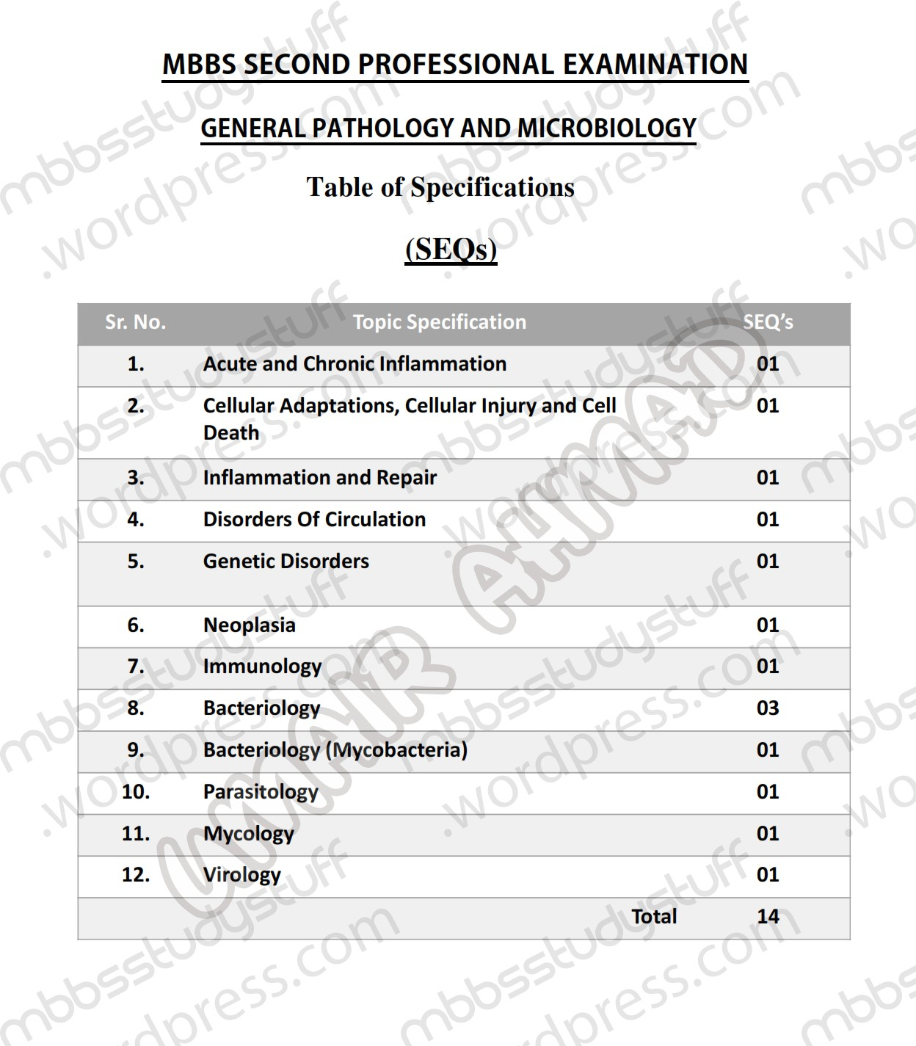

RECOMMENDED BOOKS
- Pathological Basis of Disease by Kumar, Cortan and Robbins, 10th Ed., W.B. Saunders.
- Medical Microbiology and Immunology by Levinson and Jawetz, 14th Ed., Mc Graw-Hill.
- Medical Genetics by Jorde, 3rd Ed., Mosby.
- Clinical Pathology Interpretations by A. H. Nagi

25

